Lecture/ E-learning notes

Course Code : 13 CE 31 06

Course Title : Advanced Hydraulics

Class : III B. Tech I Sem

Branch : Civil Engineering

Instructors : **Mr. N.Venkateswarlu**

**Mr. N.Sarathschandra**



Department of Civil Engineering

**N.B.K.R INSTITUTE OF SCIENCE AND TECHNOLOGY**

(AUTONOMOUS)

AFFILIATED TO JNTU, ANANTAPUR

VIDYANAGAR, SPSR NELLORE, ANDHRA PRADESH

**UNIT 1**

**INTRODUCTION TO OPEN CHANNEL FLOW**

**Introduction:**

The passage in which the liquid is not completely enclosed by a solid boundary, but has a free surface exposed to atmosphere is called open channel. The flow of liquid in this open channel is called open channel flow. It flows under atmospheric pressure due to component of gravity with a free surface. Since this flow is always associated with a free surface, it is also called free surface flow. Figure 1.1 is an example of open channel flow with hydrostatic pressure distribution.

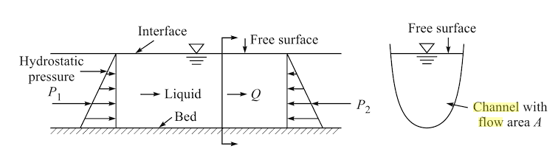**Fig 1.1 Open channel flow with hydrostatic pressure distribution**

The free surface of the flow is the interface between the moving liquid and the stationary or moving air, i.e., an interface of two fluids with different densities ρ. The pressure distribution within the liquid is always hydrostatic.

**Examples of open channel flow:**

1. Flow in natural rivers, streams, rivulets and drains
2. Flow in irrigation canal
3. Flow in sewer
4. Flow in culverts with a free surface
5. Flow in pipes not running full
6. Flow over streets after heavy rainfall

**Importance of open channel flow:**

Open channels are used to convey irrigation water under a gravitational force to the agricultural areas. These are widely used cultivation of lands drinking purpose and hydropower generation.

The open channel flow is governed by the following forces:

1. Component of gravity (W sinθ) due to bed slope (θ).
2. Inertia force: The resistance change in the velocity of liquid and it is equal to opposite direction of applied force.
3. Gravitational force causes flow in open channels in the presence of bed slope.
4. Surface tension: Mostly negligible, it is only affected when the flow depth is very small over any hydraulic structure such as spillway, weir preferably below 7 cm as seen from experiments.
5. Viscous force: small for water when flow is turbulent. It is important at low velocity and for liquids with high viscosity.
6. Force of resistance due to friction, shear-opposing gravity component due to surface roughness.
7. Wind force.

**Different types of pressures subjected in the open channel flow:**

**Atmospheric pressure:**

It is pressure exerted by air molecules on the surface of the earth at given elevation

**Hydrostatic pressure**:

It is pressure exerted by a fluid at equilibrium at a given point with in the fluid due to gravitational force.

**Differences between pipe flow and open channel flow:**

**Pipe flow:**

1. The height of Total Energy line (TEL) from datum is (Z+ p/w+ V2/2g).
2. Liquid runs full, no free surface.
3. Flow takes place under pressure.
4. Analysis of flow becomes simpler than open channel flow due to uniform cross-section
5. Hydraulic grade line (HGL) is at a height of (p/w +Z) above the datum.
6. Surface tension force is dominant if diameter is small,
7. Roughness coefficient varies from low value to high value depends on the material of pipe.
8. Velocity distribution is parabolic.
9. In pipe flow Reynolds number is ***less than 2000*** for **laminar flow** and ***more than 4000*** for **turbulent flow**.

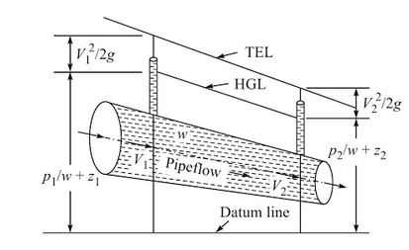

**Fig 1.2 Total energy head diagram of pipe flow**

**Open channel flow:**

1. The height of TEL from datum is (Z+y+V2/2g).
2. Open channel flow has free surface.
3. Flow takes place due to component of gravity force in the flow direction.
4. Analysis is complicated due to non-uniform cross-section bed slope and roughness.
5. HGL coincides with free surface and is at a height of (Z + y)
6. Surface tension is negligible, only considered at a very low depth.
7. Roughness coefficient varies along the depth of the flow.
8. Velocity distribution is logarithmic.
9. In pipe flow Reynolds number is ***less than 500*** for **laminar flow** and ***more than 2000*** for **turbulent flow**

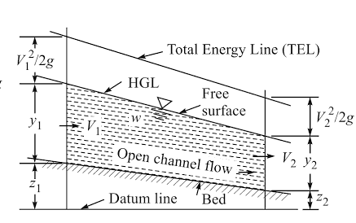

**Fig 1.3 Total energy head diagram of open channel flow**

**Types of Channels:**

**Prismatic and Non prismatic channel:**

A channel in which the cross-sectional shape and size and also the bottom slope are constant is termed as a prismatic channel. Most of the man-made (artificial) channels are prismatic channels over long stretches. The rectangle, trapezoid, triangle and circle are some of the commonly used shapes in manmade channels.

All natural channels generally have varying cross-sections and consequently are non-prismatic.

On the basis of the nature of the boundary open channel can be broadly classified into two types:

(i) Rigid channels, and (ii) mobile boundary channels.

**Based on boundary characteristics:  
 Rigid channels:**

Rigid channels are those in which the boundary is not deformable in the sense that the shape. Planiform and roughness magnitudes are not functions of the how parameters. Typical examples include lined canals, sewers and non-erodible unlined canals. The flow velocity and shear-stress distribution will be such that no major scour, erosion or deposition takes place in the channel and the channel geometry and roughness are essentially constant with respect to time. The rigid channels can be considered to have only one degree of freedom: for a given channel geometry the only change that may take place is the depth of flow which may vary with space and time depending upon the nature of the flow.

**Mobile boundary channels:**

The boundaries undergo deformation due to the continuous process of erosion and deposition due to the flow. The boundary of the channel is mobile in such cases and the flow carries considerable amounts of sediment through suspension and in contact with the bed. Such channels are classified as mobile-boundary channels. The resistance to flow, quantity of sediment transported, channel geometry and planiform, all depend on the interaction of the flow with the channel boundaries. A general mobile-boundary channel can be considered to have four degrees of freedom. For a given channel not only the depth of flow hut also the bed width, longitudinal slope and planiform (or layout) of the channel may undergo changes with space and time depending on the type of flow.

**Based on the shape:**

The following open channels are categorized based on shape

* 1. Rectangular
  2. Trapezoidal
  3. Triangular
  4. Parabolic
  5. Exponential
  6. Circular
  7. Semi circular
  8. Wide rectangular
  9. Compound channel

**Types of Flows:**

1. **Based on time (t):**
   * 1. **Steady flow**: A flow in which flow parameters such as discharge, velocity and depth do not change w.r.t time.



In a steady flow turbulent nature of flow exist due to interaction of various forces such as wind, surface tension will always be some fluctuations of the flow parameters w.r.t time. For example ripples resulting a small fluctuations of depth in a channel due to wind action over the free surface than the flow is not a unsteady in this a time of average depth is taken over sufficient time interval would indicate constant depth at a section would be taken as steady. steady flow is sub classified as (i) steady uniform flow (ii) steady gradually varied flow (iii) steady rapidly varied flow.

**(i) Steady uniform flow:**

Steady uniform flow exists only on prismatic channel. Analysis of the very simpler, in this flow is said to be steady uniform without any disturbances ripples due to wind force and surface tension.

**(ii) Steady gradually varied flow:**

This flow exists at dams and weir sections and flow is gradually increased. Analysis of flow is simpler. The gradual variation of flow exists due to obstruction like dams and weirs.

**(ii) Steady rapidly varied flow:**

This flow exists at canal drop sections and depth of flow is rapidly changes does not respect to time. Analysis of flow is simpler.

1. **Unsteady flow**: A flow in which flow parameters such as discharge, velocity and depth change w.r.t time. Analysis of unsteady flow is very complicated than steady flows, in mathematically



Unsteady flows exists widely in non-prismatic channels rarely in prismatic channels due to heavy rainfall with pool waves would be presented. Unsteady flow is sub classified as (i) Unsteady gradually varied flow (ii) Unsteady rapidly varied flow.

**(i) Unsteady gradually varied flow:**

Unsteady GVF exists during heavy rainfall in a non-prismatic channel (natural channel).

**(ii) Unsteady rapidly varied flow:**

Unsteady RVF exists at the sudden drop of the gate in hydraulic structures like dams, weirs, sluice etc.

1. **Based on variation along the length (s):**
2. **Uniform flow**: A flow in which flow parameters such as discharge, velocity and depth do not change w.r.t space (length).

In mathematically



Unsteady uniform flow never exists in any type of channel.

1. **Non uniform flow:** A flow in which flow parameters such as discharge, velocity and depth change w.r.t space (length).

In mathematically



Depth of flow varies along length of the channel

Non uniform flow or varied flow is further classified into three categories.

(i) Gradually varied flow (ii) Rapidly varied flow (iii) Spatially varied flow

**Gradually varied flow:** A flow in which depth changes gradually along length of the channel is termed as GVF.

Frictional resistance plays an important role in this flow. Depth of flow changes due to small dam or weir along the flow direction. The passage of flood wave in river is the case of unsteady gradually varied flow.

If the change of depth in a varied flow is gradual so that the curvature of streamlines is not excessive, such a flow is said to be a gradually varied flow (GVF). Frictional resistance plays an important role in these flows. The hacking up of water in a stream due to a dam or drooping of the water surface due to a sudden drop in a canal bed are examples of steady GVF. The passage of a flood wave in a river is a case of unsteady GVF.

1. **Rapidly varied flow:**

A flow in which depth changes suddenly over a short length of the channel is termed as rapidly varied flow. The frictional resistance is in significant.

If the curvature in a varied flow is large and the depth changes appreciably over short lengths, such a phenomenon is termed as rapidly varied/low (RVF). The frictional resistance is relatively insignificant in such cases and it is usual to regard RVF as a local phenomenon. A hydraulic jump occurring below a spillway or a sluice gate is an example of steady RVF. A surge moving up a canal Figure and a bore traveling up a river are examples of unsteady RVF.

1. **Spatially varied flow:**

Varied flow classified as GVF and RVF assumes that no flow is externally added to or taken out of the canal system. The volume of water in a known time interval is conserved in the channel system. In steady-varied flow the discharge is constant at all sections. However, if sonic flow is added to or abstracted from the system the resulting varied flow is known as a spatially varied flow (SVF).SVF can be steady or unsteady. In the steady SVF the discharge while being steady-varies along the channel length. The flow over a side weir is an example of steady SVF The production of surface runoff due to rainfall, known as overland flow, is a typical example of unsteady SVF.

**Classifications:**

Thus open channel flows are classified for purposes of identification and analysis as follows:

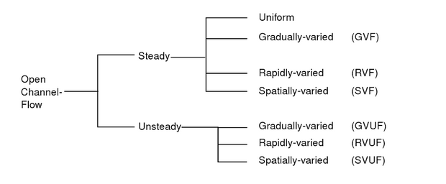

1. **Based on force due to gravity (F r): Froude’s number:**

Froude’s number: It is defined as square root of the ratio of inertial force of a flowing liquid to gravitational force. Mathematically, it is expressed as



Where, Fi = ρAV2

F g = Force due to gravity

= Mass x Acceleration due to gravity

= ρ x Volume x g

= ρ x A x L x g



Based on Froude’s number the following flows are classified as

(i) Critical flow

(ii) Sub critical flow

(iii) Super critical flow

1. **Critical flow:** A flow is said to be critical, if froude’s number equal to one

F r = 1 (critical flow)

1. **Sub critical flow:** A flow is said to be critical, if froude’s number less than one

F r< 1 ( sub critical flow)

1. **Super critical flow:** A flow is said to be critical, if froude’s number more than

F r> 1 (super critical flow)

**Based on viscous force: Reynolds number:**

Reynolds number: It is the ratio of inertial force of liquid to the viscous force.

Based on Reynolds number flows are classified as

(i) Laminar flow

(ii) Turbulent flow

(iii) Transition flow

1. Laminar flow: It is very smooth paths, parallel bands and without intersection of stream lines.
2. Turbulent flow: It is irregular paths; irregular bands and stream lines are intersected.
3. Transit flow: The combination of laminar turbulent flow is termed as transit flow.
4. **Based on density:**
5. Homogenous flow: The density of a liquid is same throughout length of channel.
6. Stratified flow: The density id different at different sections.
7. **Based on coordinate system:**
8. 1 D flow
9. 2 D flow
10. 3 D flow

**Geometrical parameters in open channel flow:**

Depth of channel: The perpendicular distance between free surface and channel bed.

Depth of flow: The vertical distance from free water surface to the channel bed.

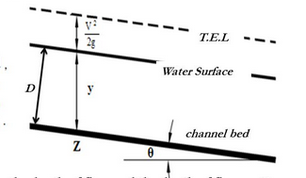

**Fig Longitudinal section**

Where, D = Depth of channel, y = depth of flow and θ = bed slope



If θ = 0, y = D

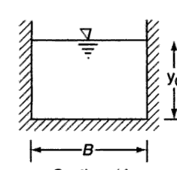

**Fig Channel cross-sectional area**

Let b be the bottom width T be the top width; and y is depth of flow.

Hydraulic radius of channel is taken as R = A/P

Hydraulic depth is D = A/T

Section factor Z c=  here, A is wetted area and P is wetted perimeter.

1. **Rectangular cross section:**

Let B, y and θ be the bottom width, depth of the flow and bed slope or longitudinal slope

as in in fig.

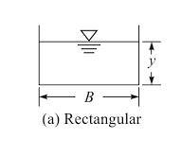

Fig Rectangular section

|  |  |  |  |
| --- | --- | --- | --- |
| S.No | Parameters |  | formulae |
| 1 | Wetted area (A) | = | By |
| 2 | Wetted perimeter (P) | = | B+2y |
| 3 | Hydraulic radius ( R= A / P ) | = |  |
| 4 | Hydraulic depth (D = A / T ) | = |  |
| 5 | Section factor (Z= ) | = | By |

1. **Triangular cross section:**

Let T, y, 1V: nH and θ be the bottom width, depth of the flow, side slope and bed slope or longitudinal slope as in in fig.

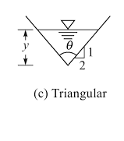

|  |  |  |  |
| --- | --- | --- | --- |
| S.No | Parameters |  | formulae |
| 1 | Wetted area (A) | = |  |
| 2 | Wetted perimeter (P) | = | 2y |
| 3 | Hydraulic radius ( R= A / P ) | = |  |
| 4 | Hydraulic depth (D = A / T ) | = |  |
| 5 | Section factor (Z= ) | = |  |

1. **Trapezoidal cross section:**

Let T, y, 1V: nH and θ be the bottom width, depth of the flow, side slope and bed slope or longitudinal slope as in fig.

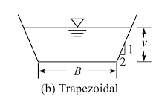

|  |  |  |  |
| --- | --- | --- | --- |
| S.No | Parameters |  | formulae |
| 1 | Wetted area (A) | = |  |
| 2 | Wetted perimeter (P) | = | B + 2y |
| 3 | Hydraulic radius ( R= A / P ) | = |  |
| 4 | Hydraulic depth (D = A / T ) | = |  |
| 5 | Section factor (Z= ) | = |  |

1. **Circular cross section:**

Let r, θ be the radius and angle made from centre to the free surface as shown in figure

**If θ <180˚**

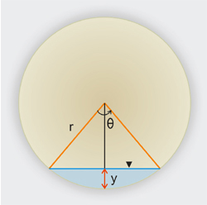

D

B

C

A

Fig Circular cross section

Wetted area = Sector area ADBC - ∆le area ACB

= 

= 

Wetted area = 

Wetted perimeter (P) = r θ

**If θ >180˚**

D

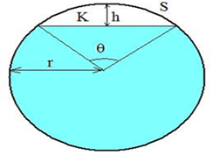

C

B

A

Wetted area = Sector area ADBC + ∆le area ACB

= 

= 

Wetted area = 

Wetted perimeter (P) = r θ

**Velocity distribution:**

The presence of corners and boundaries in an open channel causes the velocity vectors of the flow to have components not only in the longitudinal and lateral direction but also in normal direction to the flow. In a macro-analysis, one is concerned only with the major component, viz., the longitudinal component, y,. The other two components being small are ignored and v is designated as y. The distribution of y in a channel is dependent on the geometry of the channel. Figure 1.2(a) and (b) show isovels (contours of equal velocity) of y for a natural and rectangular channel respectively. The influence of the channel geometry is apparent. The velocity V is zero at the solid boundaries and gradually increases with distance from the boundary. The  
maximum velocity of the cross-section occurs at a certain distance below the free surface. This dip of the maximum velocity point, giving surface velocities which are less than the maximum velocity, is due to secondary currents and is a function of the aspect ratio (ratio of depth to width) of the channel. Thus for a deep narrow channel, the location of the maximum velocity point will be much lower from the water surface than for a wider channel of the same depth. This characteristic location of the maximum velocity point below the surface has nothing to do with the wind shear on the free surface.

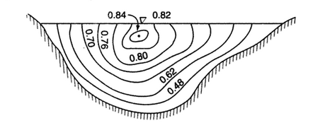

Fig Velocity distribution in natural channel

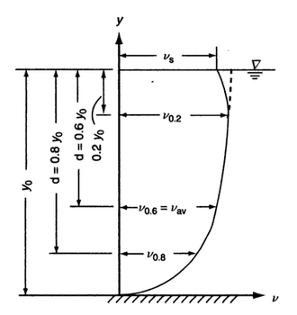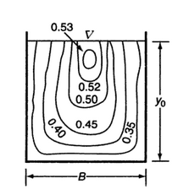

**Fig** Typical velocity profile for rectangular channel **Fig** rectangular channel cross-section

A typical velocity profile at a section in a plane normal to the direction of flow is presented in Fig. 1.2(c). The profile can be roughly described by a logarithmic distribution or a power-law distribution up to the maximum velocity point (Section 3.7).

Field observations in rivers and canals have shown that the average velocity at any vertical v, occurs at a level of 0.6 y0 from the free surface, where yo = depth of flow.

Further, it is found that



In which y0, = velocity at a depth of 0.2 yo from the free surface, and = velocity at a depth of 0.8 yo from the free surface. This property of the velocity distribution is commonly used in stream-gauging practice to determine the discharge using the  
area-velocity method.



The surface velocity y, is related to the average velocity m as where, k = a coefficient with a value between 0.8 and 0.95. The proper value of k depends on the channel section and has to be determined by field calibrations. Knowing k, one can estimate the average velocity in an open channel by using floats and other surface velocity measuring devices.

**Velocity distribution coefficients:**

The velocity distribution in open channels is not uniform. The non-uniform distribution in open channel flow affects the computation of velocity head (KE head).The actual velocity head is more than the computed velocity head.

The actual velocity head may be expressed as K.E = α is known as Kinetic energy coefficient or Coriolis Effect.it been estimated by the experiments that α varies from 1.03 to 1.36 for a fairly straight prismatic channel. The value is generally higher for small channels and lower for large rivers of greater depths. This non-uniform velocity distribution also affects the computation of momentum in open channel flow. Actual momentum of liquid passing through channel section per unit time is expressed by

M = 

Where, β is the momentum coefficient or Boussinesq coefficient.

It is found that the value of β varies from 1.01 to 1.12 for fairly straight prismatic channel. The velocity distribution coefficient α and β is slightly greater than the unity which is the limiting velocity for strictly uniform velocity distribution across the channel section. For channels of regular cross section and fairly straight alignment the effect on non-uniform velocity distribution in both velocity and momentum is small. Therefore, in such channels α and βare assumed to be unity. In the case channel of complex cross section, the values for both the coefficients may be higher, i.e., α and β may go upto 1.6 and 1.2 respectively. The values of the coefficients may be close to 2 in places such as upstream from weirs, in the vicinity of obstructions or near pronounced irregularities in alignment. For a given channel section and velocity distribution, α is much more sensitive to variation in velocity than β.

**Determination of equation of energy coefficient (α):**

Let c be the elementary area of the whole cross sectional area A of the channel and w is the specific weight of liquid flowing in a channel. The weight of water passing through ∆A with velocity v is w (∆A v).

Mass of this is 

Kinetic energy KE of water passing through ∆A = 

KE = 

KE = 

KE of whole area A = 

Now, taking the whole area A, the mean velocity V, the corrected velocity head, we get

Total KE = = 

 = 





Which is general equation of α. If channel is rectangular, dA = B dy, A = Byo





**Determination of equation of momentum coefficient (β):**

Momentum passing with velocity v through the elemental area dA = 

Total momentum =  ……..Eq (1)

Based on the momentum principle the actual momentum of flowing liquid

= …………Eq (2)

Equating both equations

 = 

= 

β = 

This is general equation of β.

If the channel is rectangular dA = B dy, A = By0



**UNIT -2**

**UNIFORM FLOW**

**Uniform flow:**

Uniform flow relates to a flow condition over a certain length or reaches of a stream and can occur only during steady flow conditions. Uniform flow may be also defined as the flow occurring in a channel in which equilibrium has been reached between gravitational force and shear force. Many irrigation and drainage canals and other artificial channels are designed to carry water at uniform depth and cross section all along their lengths. Natural channels as rivers and creeks are seldom of uniform shape. The design discharge is set by considerations of acceptable risk and frequency analysis, whereas the channel slope and the cross-sectional shape are determined by topography, and soil and land conditions.

**Momentum equation:**

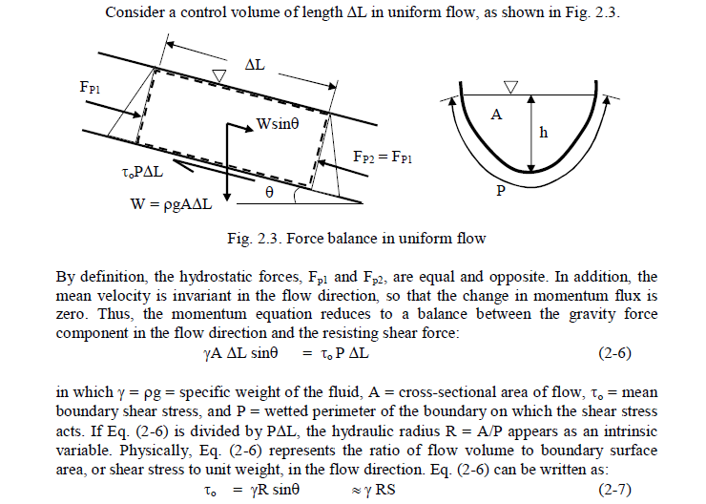

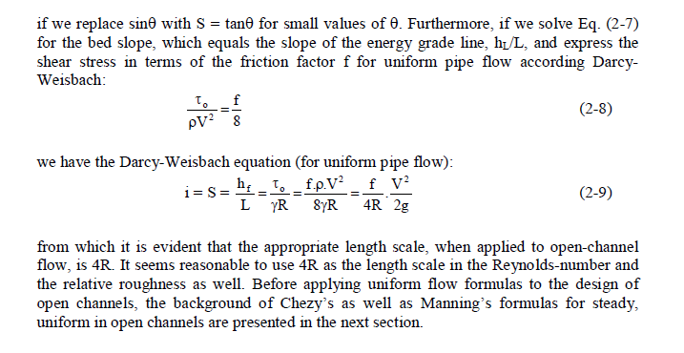

**The Chezy’s equation:**

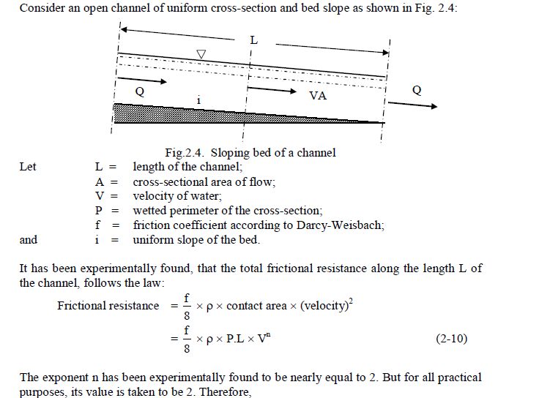

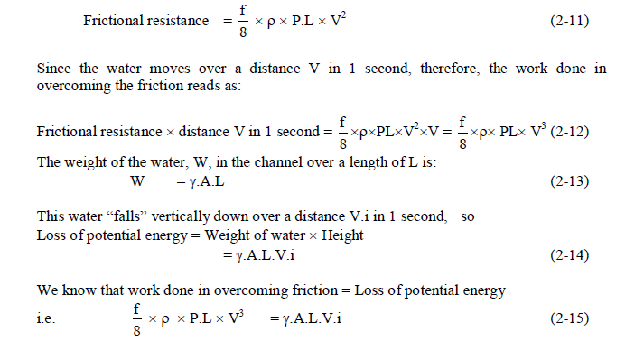

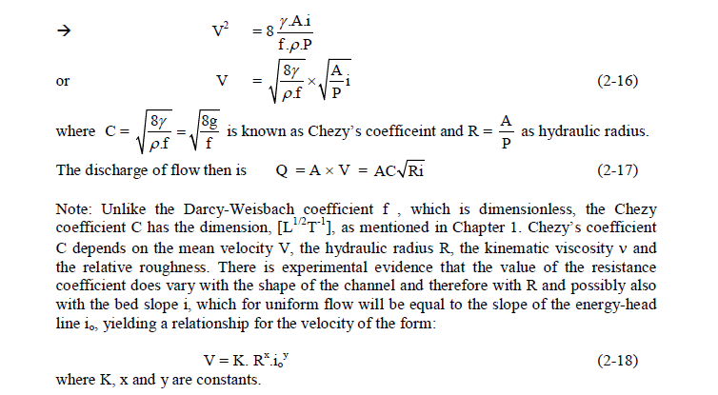

**The Manning’s equation:**

A very many studies have been made of the evaluation of C for different natural and manmade channels. These have resulted in today most practicing engineers use some form of this relationship to give C:

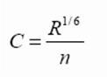

This is known as Manning’s formula and the *n* as Manning’s *n*. Substituting equation 1.9 in to 1.10 gives velocity of uniform flow:

Or in terms of discharge

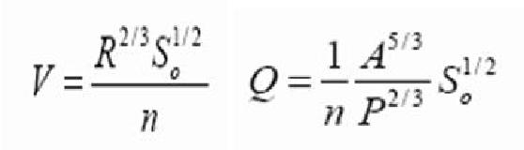

**Note:**

Several other names have been associated with the derivation of this formula – or ones similar and consequently in some countries the same equation is named after one of these people. Some of these names are; Strickler, Gauckler, Kutter, Gauguillet and Hagen.

The Manning’s *n* is also numerically identical to the Kutter *n*.

The Manning equation has the great benefits that it is simple, accurate and now due to it long extensive practical use; there exists a wealth of publicly available values of *n* for a very wide range of channels.

Below is a table of a few typical values of Manning’s *n*

**Table 2.1 Manning’s roughness coefficient for various channels**

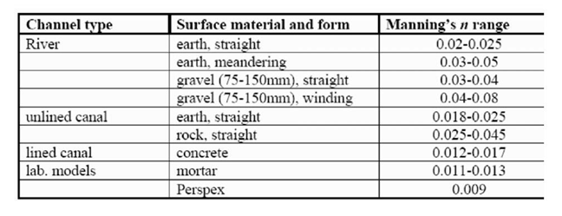

**Conveyance**

Channel conveyance, *K* , is a measure of the carrying capacity of a channel. The *K* is really an agglomeration of several terms in the Chezy’s or Manning's equation:

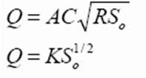

So

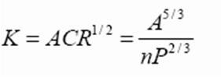

Use of conveyance may be made when calculating discharge and stage in compound channels and also calculating the energy and momentum coefficients in this situation.

**Best Hydraulic Cross- Section:**

We often want to know the minimum area A for a given flow Q, slope S0 and roughness coefficient *n*.

This is known as the best hydraulic cross section

The quantity ARh2/3 in Manning’s’ equation is called the *section factor* Writing the Manning equation with Rh = A/P, we get

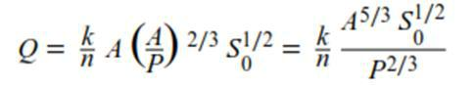

Rearranged we get

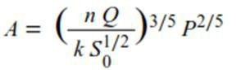

**Most economic channel section:**

It is known that the conveyance of a channel section increases with increases in hydraulic radius or with decrease in the wetted perimeter. From hydraulics viewpoint, therefore, the channel section having the least wetted perimeter for a given area has the maximum conveyance; such a section is known as the best hydraulic section.

Of all the possible open channel sections, the semicircular shape has the least amount of perimeter for a given area. Relationship between various geometric elements to form an efficient section can be obtained as follows.

**Rectangular channel section:**

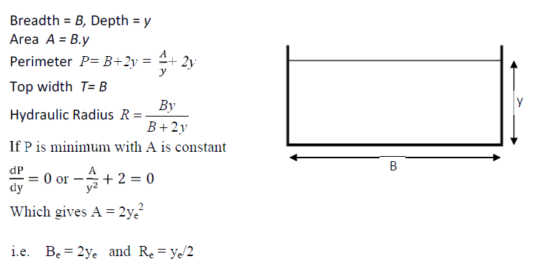

**Triangular channel section:**

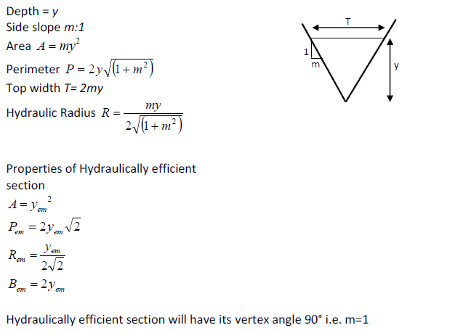

**Trapezoidalchannel section:**

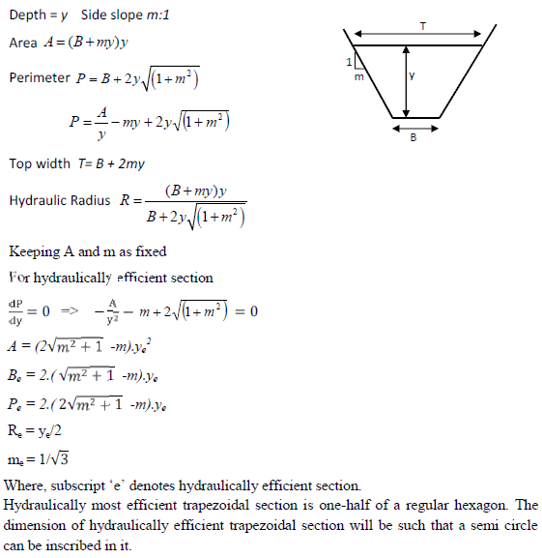

**Circular channel section:**

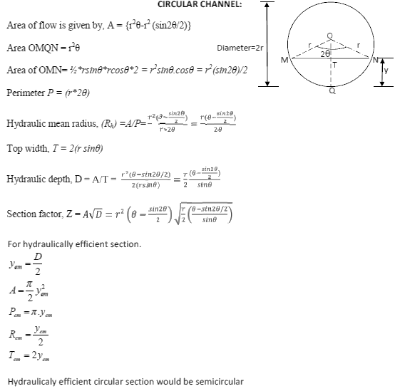

Problems on uniform flow:

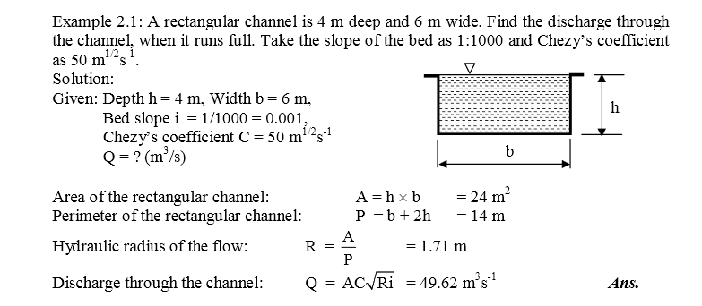

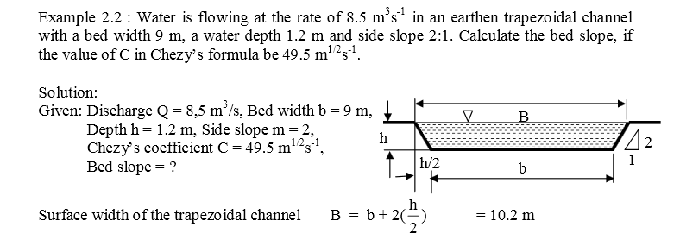

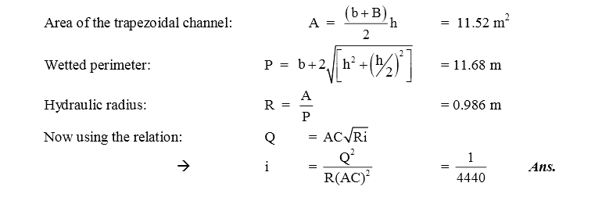

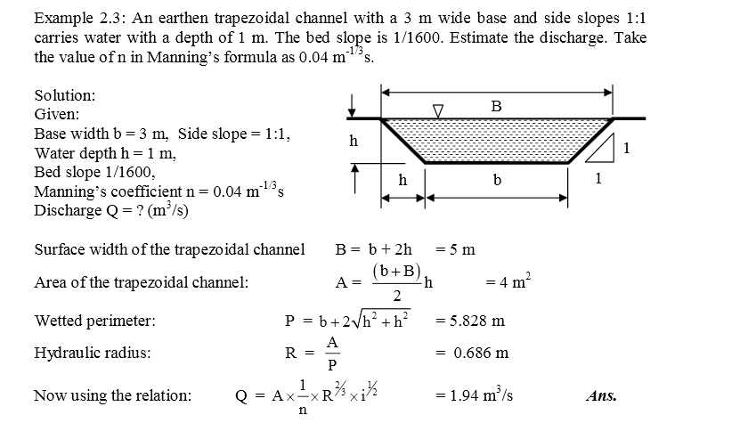

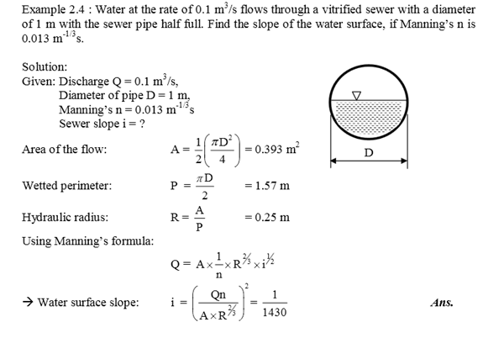

**UNIT 3**

**SPECIFIC ENERGY AND CRITICAL DEPTH**

**Introduction:**

The concept of specific energy introduced by Bakhmeteff is very useful in defining critical water depth and in the analysis of open channel flow. It may be noted that while the total energy in a real fluid flow always decreases in the downstream direction. The specific energy is constant for a uniform flow and can either decrease or increase in a varied flow, since the elevation of the bed of the channel relative to the elevation of the energy line, determines the specific energy.

If the datum coincides with the channel bed at the cross-section, the resulting expression is known as *specific energy* and is denoted by E. Thus, *specific energy* is the energy at a cross-section of an open channel flow with respect to the channel bed.

The total energy of a channel flow referred to datum is given by,



Specific energy at a cross-section is,



Here, cross-sectional area A depends on water depth y and can be defined as, A = A(y). Examining the Eq. (5.2) show us that, there is a functional relation between the three variables as,



In order to examine the functional relationship on the plane, two cases are introduced.

1. Q = Constant = Q1 → E = f (y, Q1).

Variation of the specific energy with the water depth at a cross-section for a given discharge is Q1.

1. E = Constant = E1 → E1 = f (y, Q)

Variation of the discharge with the water depth at across-section for a given specific energy is E1.

**Specific energy curve:**

The specific energy equation can be written as

 Here 

The equation shows that for a given discharge Q and channel section, Specific energy E is function of depth only. When depth of flow y is plotted against specific energy E, Specific energy diagram or curve is obtained.

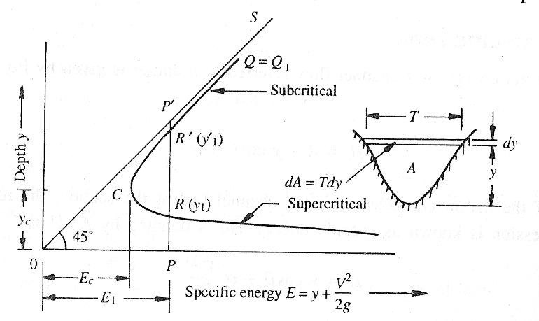

Fig3.1: Specific energy curve

**Characteristics of specific energy curve:**

For a channel of known geometry, E = f (y, Q). Keeping Q = constant = Q1, the variation of E with y is represented by a cubic parabola. (Fig.3.1). It is seen that there are two positive roots for the equation E indicating that any particular discharge Q1 can be passed in a given channel at two depths and still maintain the same specific energy E1. The depths of flow can be either PR = y1 or PR’ = y’1. These two possible depths having the same specific energy are known as *alternate depths*. In Fig. (3.1), a line (OS) drawn such that E = y (i.e. at 450 to the abscissa) is the asymptote of the upper limb of the specific energy curve.

It may be noticed that the intercept P’R’ and P’R represents the velocity head. Of the two alternate depths, one (PR = y1) is smaller and has a large velocity head while the other (PR’= y’1) has a larger depth and consequently a smaller velocity head. For a given Q, as the specific energy is increased the difference between the two alternate depths increases. On the other hand, if E is decreased, the difference (y’1 – y1) will decrease and a certain value E = Ec, the two depths will merge with each other (point C in Fig. 3.1). No value for y can be obtained when E < Ec, denoting that the flow under the given conditions is not possible in this region. The condition of minimum specific energy is known as the *critical flow condition* and the corresponding depth *yc* is known as *critical depth*.

The specific energy diagram can be plotted for discharges Q = Qi = constant (i = 1, 2, 3,…) as in Fig. (3.2). as the discharges increase, the specific energy curves moves right since the specific energy increases with the discharge.

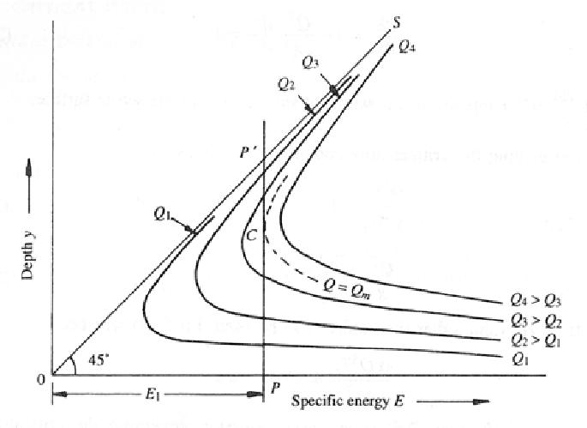

**Figure 3.2** Specific energy for varying discharges

**Conditions of critical flow:**

The condition of minimum specific energy at a given value of Q may be obtained as



AS Q is constant, differentiating E with respect to depth y and equating to zero for minimum, we get







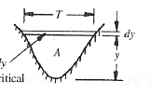

Fig3.1: Sectional view

Consider a channel of top width T and cross sectional area A as shown in fig.3.2.Let *dy* be the elemental depth. And *y* is the depth of flow.







The above mathematical expression is condition for minimum specific energy.

Equation may be simplified as





The above equation shows velocity head is half of the hydraulic depth D, which is one criteria of critical flow condition.

Further above equation may be simplified and written as







By the definition  is the equation of Froude’s number,



i.e., *Fr*= 1 hence flow is critical

it may be concluded that at minimum specific energy for a given discharge for a given discharge flow condition is always critical state, so the mathematical representation is the condition of critical flow of the channel.

**Maximum discharge at a given specific energy:**

The equation is







The above equation may be differential with respect to y keeping E to be constant and Q to be maximum,

 For maximum discharge Q.



 







Therefore, 

**Critical flow computations:**

**Rectangular Cross-Section:**



T=B

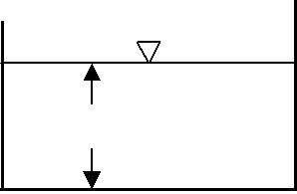

*y*

**Figure 3.2**

Analytically general expression for critical flow condition of channel is



In rectangular channel A = B *y*c, T = B  discharge per unit width.

The equation becomes



 





i.e. explicit or direct solution of critical depth in rectangular channel exists. To find the corresponding specific energy at critical depth.







**Triangular channel:** General condition is



;  When side slope 1V: nH







i.e. explicit or direct solution of critical depth in triangular channel exists. To find the corresponding specific energy at critical depth.





 

**Trapezoidal channel:** General condition is



;  When side slope 1V: nH



Therefore, the above equation doesn’t exist direct solution. So it is implicit equation.

The above equation can be expressed as



 

The above equation is converted into Non-dimensional form. Here  is

Non-dimensional discharge. And non-dimensional discharge is 



**Example 3.1:** Calculate the critical depth and the corresponding specific energy for adischarge of 5.0 m3/s in the following channels.

1. Rectangular channel, B = 2.0 m.
2. Triangular channel, n = 0.5.
3. Trapezoidal channel, B = 2.0 m, n = 1.5.

Sol:

Rectangular channel, B = 2.0 m. Q = 5.0 m3/s

Critical depth for rectangular channel 

q =  =





Triangular channel, n = 0.5. 



Trapezoidal channel, B = 2.0 m, n = 1.5.

 here 





The concepts of specific energy and critical energy are useful in the analysis of transition problems. Transitions in rectangular channels are presented here. The principles are equally applicable to channels of any shape and other types of transitions.

**Channel with a Hump**

**a) Subcritical Flow**

Consider a horizontal, frictionless rectangular channel of width B carrying discharge Q at depth y1.

Let the flow be subcritical. At a section 2 (Fig. 5.11) a smooth hump of height ∆Z is built on the floor. Since there are no energy losses between sections 1 and 2, construction of a hump causes the specific energy at section to decrease by ∆Z. Thus the specific energies at sections 1 and 2 are,





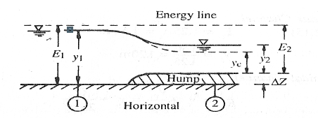

**Fig 3.5 Channel with a hump**

Since the flow is subcritical, the water surface will drop due to a decrease in the specific energy. In Fig. (3.6), the water surface which was at Pat section 1 will come down to point Rat section 2. The depth y2 will be given by,



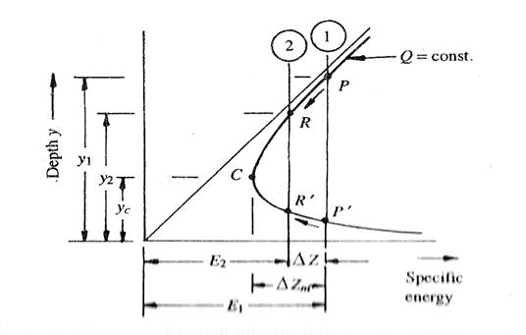

**Figure 3.6.** Specific energy diagram for Fig. (3.5)

It is easy to see from Fig. (3.6) that as the value of ∆Z is increased, the depth at section 2, y2, will decrease. The minimum depth is reached when the point R coincides with C, the critical depth. At this point the hump height will be maximum, ∆Z max, y2 = yc = critical depth, and E2 = Ec = minimum energy for the flowing discharge Q. The condition at ∆Zmax is given by the relation,



The question may arise as to what happens when Z > Zmax. From Fig. (3.6) it is seen that the flow is not possible with the given conditions (given discharge). The upstream depth has to increase to cause and increase in the specific energy at section 1. If this modified depth is represented by y1`,



At section 2 the flow will continue at the minimum specific energy level, i.e. at the critical condition. At this condition, y2 = yc, and



Recollecting the various sequences, when 0 < ∆Z < ∆Zmax the upstream water level remains stationary at y1 while the depth of flow at section 2 decreases with ∆Z reaching a minimum value of yc at ∆Z = ∆Zmax. (Fig.3.6).With further increase in the value of ∆Z, i.e. for ∆Z > ∆Zmax, y1 will change to y1` while y2 will continue to remain yc.

The variation of y1 and y2 with Z in the subcritical regime can be clearly seen in Fig.

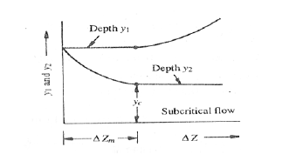

**Fig 3.7** Variation of y1 and y2 in subcritical flow over a hump

**Super critical flow:**

If y1 is in the supercritical flow regime, Fig. (3.6) shows that the depth of flow increases due to the reduction of specific energy. In Fig. (3.6) point P` corresponds to y1 and point R` to depth at the section 2. Up to the critical depth, y2 increases to reach yc at Z =∆Zmax. For ∆Z > ∆Zmax, the depth over the hump y2 = yc will remain constant and the upstream depth y1 will change. It will decrease to have a higher specific energy E1`byincreasing velocity V1. The variation of the depths y1 and y2 with Z in the supercritical flow is shown in Fig. (5.15).

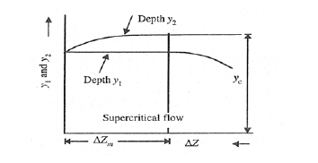

**Figure 3.8** Variation of y1 and y2 in supercritical flow over a hump

**Transition with a Change in Width:**

**Subcritical Flow in a Width Constriction**

Consider a frictionless horizontal channel of width B1 carrying a discharge Q at a depth y1 as in Fig. (5.17). at a section 2 channel width has been constricted to B2 by a smooth transition. Since there are no losses involved and since the bed elevations at sections 1 and 2 are the same, the specific energy at section is equal to the specific energy at section 2.

It is convenient to analyze the flow in terms of the discharge intensity q = Q/B. At section 1, q1 = Q/B1 and at section 2, q2 = Q/B2. Since B2 < B1, q2 > q1. In the specific energy diagram (Fig. 5.19) drawn with the discharge intensity, point P on the curve q1 corresponds to depth y1 and specific energy E1. Since at section 2, E2 = E1 and q = q2, point P will move vertically downward to point R on the curve q2 to reach the depth y2. Thus, in subcritical flow the depth is y2 < y1. If B2 is made smaller, then q2 will increase and y2 will decrease. The limit of the contracted width B2 = B2min is reached when corresponding to E1, the discharge intensity q2 = q2max, i.e. the maximum discharge intensity for a given specific energy (critical flow condition) will prevail.

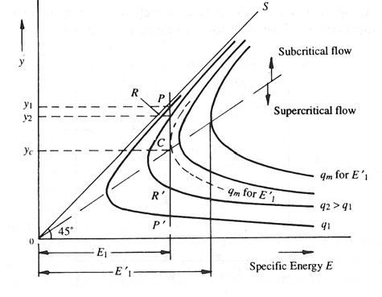

**Figure 3.9** Specific energy diagram for Fig.

At min width 



For rectangular channel at critical 

Since 

;  

If B2 < B2min, the discharge intensity q2 will be larger than qmax, the maximum discharge intensity consistent E1. The flow will not, therefore, be possible with the given upstream conditions. The upstream depth will have to increase to y1`. The new specific energy will be formed which will be sufficient to cause critical flow at section 2. It may be noted that the new critical depth at section 2 for a rectangular channel is,



Since B2 < B2min, yc2 will be larger than ycm, yc2 > ycm. Thus even though critical flow prevails for all B2 < B2min, the depth section 2 is not constant as in the hump case but increases as y1` and hence E1` rises. The variation of y1, y2 and E with B2/B1 is shown schematically in Fig. (5.20).







Fig Variation of y1 and y2 in subcritical flow in a width constriction

**Supercritical Flow in a Width Constriction:**

If the upstream depth y1 is in the supercritical flow regime, a reduction of the flow width and hence an increase in the discharge intensity cause a rise in depth y2. In Fig. (5.19), point P` corresponds to y1 and point R` to y2. As the width B2 is decreased, R` moves up till it becomes critical at B2 = B2min. Any further reduction in B2 causes the upstream depth to decrease to y1` so that E1 rises to E1`. At section2, critical depth yc` corresponding to the new specific energy E1` will prevail. The variation of y1, y2 and E with B2/B1 in supercritical flow regime is indicated in Fig. (5.21).

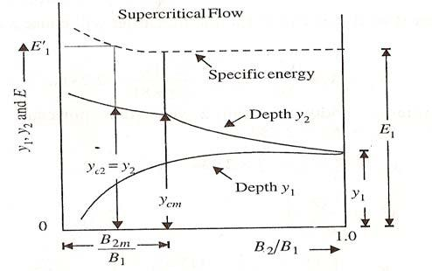

**Fig** **Variation of y1 and y2 in supercritical flow in a width constriction**

In the case of a channel with a hump, and also in the case of a width constriction, it is observed that the upstream water surface elevation is not affected by the conditions at section 2 till a critical stage is first achieved. Thus in the case of a hump for all Z ≤ Zmax, the upstream water depth is constant and for all Z > Zmax the upstream depth is different from y1. Similarly, in the case of the width constriction, for B2 ≥ B2min, the upstream depth y1 is constant; while for all B2 < B2min, the upstream depth undergoes a change. This onset of critical condition at section 2 is a prerequisite to choking. Thus all cases with Z > Zmax or B2 < B2min are known as *choked conditions*. Obviously, choked conditions are undesirable and need to be watched in the design of culverts and other surface drainage features involving channel transitions.

**Example3.1:**

In rectangular channel carries the discharge of 5m3/s and width 2m with a depth of flow 1.8m A hump is constricted of height 0.5m calculate new upstream depth of flow if necessary.

**Sol: **



**  2**

The critical depth of flow  yc = 0.861m 

Minimum specific energy  Ec = 1.2915m

Here, Ec is less than E2 therefore, upstream depth remains unchanged.



**Example3.2:** A rectangular channel is 3m wide and carries a discharge of 3.3m3/s at a depth of 0.9m. A smooth contraction of the channel width proposed at a section. Find the smallest contracted width that will not affect the upstream flow conditions. Neglect energy losses in the transitions.

Let suffixes 1 & 2 refer to the section upstream and downstream of the transition

At section 1-1: B1 = 3.0m y1 = 0.9m and Q = 3.3m3/s



The flow in the channel is in subcritical mode and the water surface elevation will drop in the contracted section.

Specific energy 

At the maximum possible contraction of width that will not affect the upstream flow condition the critical flow will prevail at the contracted section. Thus 

Since there is no energy loss 

Hence 

Since the cross section of the channel at section 2 is rectangular



Width of the contracted section 

**UNIT 4**

**GRADUALLY VARIED FLOW**

A steady non-uniform flow in a prismatic channel with gradual changes in its water surface elevation is termed as gradually varied flow (GVF). The backwater produced by a dam or weir across a river and the drawdown produced at a sudden drop in a channel are few typical examples of GVF. In a GVF, the velocity varies along the channel and consequently the bed slope, water surface slope, and energy slope will all differ from each other.

Regions of high curvature are excluded in the analysis of this flow.

The two basic assumptions involved in the analysis of GVF are the following:

1. The pressure distribution at any section is assumed to be hydrostatic. This  
   follows from the definition of the flow to have a gradually-varied water surface. As gradual changes in the surface curvature give rise to negligible normal accelerations, the departure from the hydrostatic pressure distribution is negligible. The exclusion of the region of high curvature from the analysis of GVF, as indicated earlier, is only to meet this requirement.
2. The resistance to flow at any depth is assumed to be given by the corresponding uniform flow equation, such as the Manning’s formula, with the condition that the slope term to be used in the equation is the energy slope and not the bed slope. Thus, if in a GVF the depth of flow at any section is y, the energy slope S, is given by

The depth of flow changes along its length of the channel.

Gradually varied flow may be caused due to various factors.

Change in the shape of cross section. The channel reaches at downstream of sluice gate.

Presence of obstructions (weirs & dams)

Change in shape over the length.

Change in frictional forces at channel bottom.

The gradually varied flow concept mainly concerned with the predicting or estimating water surface curves or profiles and computing their length.

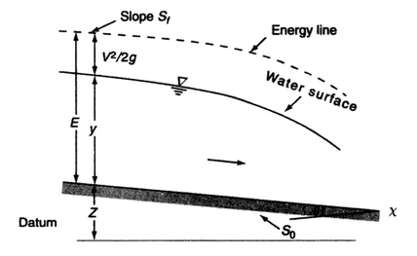

**Fig 4.1 Definition sketch of gradually varied flow**

**The dynamic equation of gradually varied flow:**

* 1. Flow is steady
  2. Channel is prismatic
  3. Kinetic energy coefficient is unity (α = 1)
  4. Pressure distribution is hydrostatic.
  5. Stream lines are straight and practically parallel with each other.
  6. Frictional forces are same throughout channel reach.
  7. Chezy’s & manning’s roughness coefficients are commonly applicable to the GVF channel.
  8. Bed slope is mild.

Consider a profile of gradually varied flow in the elementary length dx. And controlled volume is considered in between section (1)-(1) & (2)-(2).

Let Z1, Z2 be the datum heads at section (1)-(1) & (2)-(2).

Let y1, y2 be the depths of flow at section (1)-(1) & (2)-(2).

V1, V2 be the velocities at section (1)-(1) & (2)-(2).

Sb, Se (or) Sf is the slope of channel bottom and slope of energy line respectively.

From Bernoulli’s equation

The total energy head of general form can be written as 

Differentiate H w.r.t elementary length dx.



Here,  is rate of change of total energy head w.r.t to elementary length of the channel. If length increases total energy head will decrease

Therefore,  is taken as (-) ve.

 is the slope of energy line (or) frictional slope.

Therefore, 

Here,  is the rate of change of datum head w.r.t elementary length of the channel.

If *x* increases along with flow datum head will decrease

Therefore,  is taken as (-) ve.



The above parameters are substituted in total energy equation







 …………. Eq (4.1)

The above equation is general form of dynamic equation of gradually varied flow.

Consider a prismatic channel of flow steady and top width T, depth of flow y as shown in figure.

Elementary area  



 …………. Eq (4.2)

**Classifications of Gradually varied flow profiles:**

The various surface profiles may be classified into twelve different types according to the nature of the channel slope and the zone in which the flow surface lies.

**M1- Profile:**

This is a backwater curve and it lies in zone-1 of mild channel. This profile occurs where the D/S end of a long mild channel is submerged in a reservoir to a depth greater than normal depth of flow in the channel. The example may be profile behind a dam in a natural river or a profile in a canal joining two reservoirs.

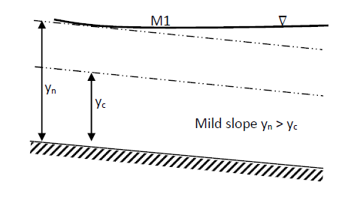

**Fig 4.2 M1- Profile:**

**M2-Profile:**

This is a draw down curve and it lies in Zone-II of a mild channel. If the depth of submergence on the D/S end is greater than  then only that much profile will be formed, which lies above the water surface at the D/S end. For example, profile at D/S end of a mild channel having free over fall.

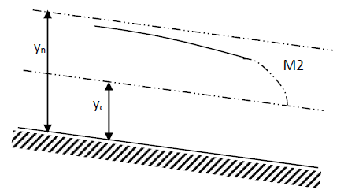

**Fig 4.3 M2-Profile**

**M3-Profile:**

This profile is a backwater curve which lies in Zone III of a mild channel. It starts from the upstream channel bottom and terminates with a hydraulic jump at the D/S end. It occurs when a supercritical flow enters a mild channel. For example: Profile in a stream below a sluice gate and profile after the change in bottom slope from steep to mild.

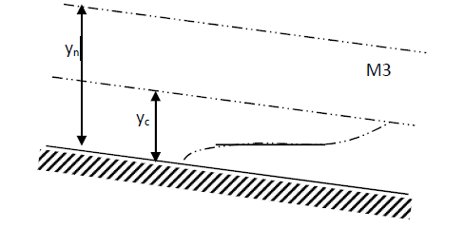

**Fig4.4 M3-Profile**

**S1-Profile:**

This is a backwater curve, which lies in Zone-1 of a steep channel. It begins with a jump at the U/S and becomes tangent to the horizontal pool level at the D/S end. For example: Profiles of flow behind a dam in a steep channel or in a steep canal emptying into a pool of high elevation.

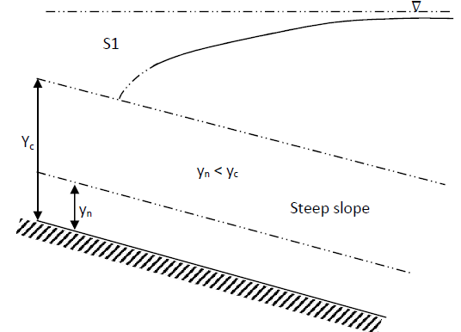

**Fig4.5 S1-Profile**

**S2-Profile:**

This is a draw down curve which lies in Zone-2 of a steep channel. It is usually very short and rather like a transition between a hydraulic drop and uniform flow. Since it starts U/S with a vertical slope at the critical depth and is tangent to the normal- depth line at the D/S end. For example, profiles formed on the D/S side of an enlargement of channel section and on the steep slope side as the channel slope changes from steep to steeper.

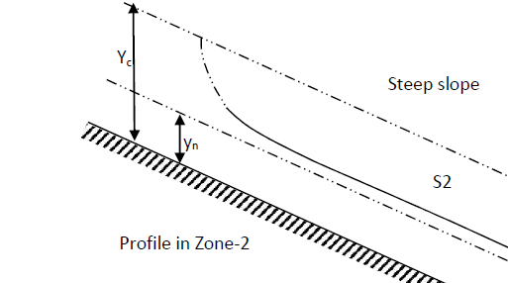

**Fig4.6 S2-Profile**

**S3-Profile:**

This is a backwater curve, which lies in Zone-III of a steep channel. For example, profile on steep slope as the channel slope changes from steep to milder steep and that below a sluice with the depth of the entering flow less than the normal depth on a steep slope.

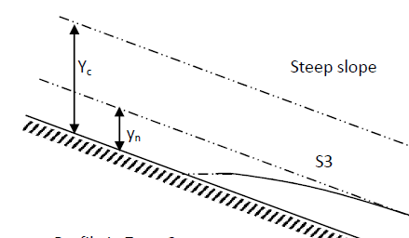

**Fig 4.7 S3-Profile**

**C-Profiles:**

Since, S0 =Sc and, these profiles represent the transition condition between

M and S profiles. For a wide rectangular channel if Manning’s formula is used, C1 and C3 profiles are used but when Chezy’s formula is used, both these profiles are horizontal lines,

since, .

**C1-Profile:**

This is a backwater curve, which lies in Zone-I of a critical sloped channel. For example, profile formed on the critical slope side of the channel having a break in the bottom slope in which the critical slope changes to a mild slope.

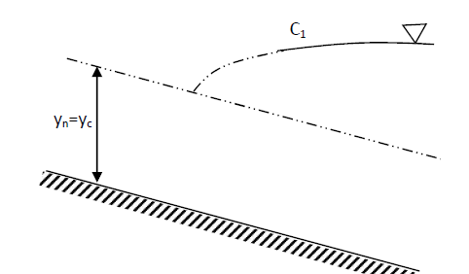

**Fig 4.8 C1-Profile**

**C3-Profile:**

This is a back water curve which lies in Zone-III of a critical sloped channel. The U/S end of the curve starts theoretically from the channel bottom. At the D/S end the profile terminates with a hydraulic jump occurs where a supercritical flow enters a critical sloped channel. For example, Profile in a stream below a sluice gate provided in a critical sloped channel.

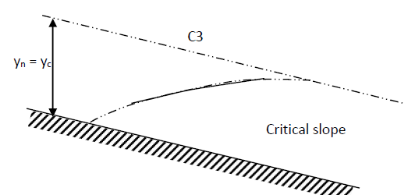

**Fig 4.8 C3-Profile**

**H2-Profile:**

It is a drawdown curve, which lies in Zone-II of a horizontal channel. The U/S end of the H2 profile tends to approach horizontal line tangentially while the D/S end of the profile tends to meet the C.D.L perpendicularly, thus ending in a hydraulic drop. For example, profile at D/S end of a horizontal channel having a free over fall.

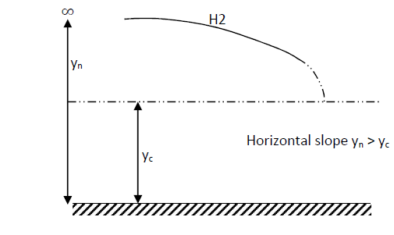

**Fig 4.9 H2-Profile**

**H3-Profile:**

It is a backwater curve which lies in Zone-III of a horizontal channel. The U/S end of H3 profile starts theoretically from the channel bottom while the D/S end of the profile terminates with a hydraulic jump occurs when a supercritical flow enters a horizontal channel. For example**,** profile in a stream below a sluicegate provided in a horizontal channel.

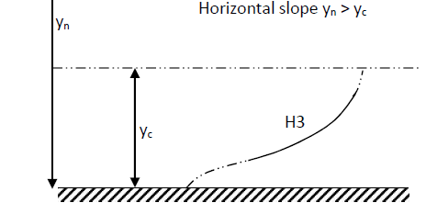

**Fig 4.10 H2-Profile**

**A2-Profile:**

It is a draw down curve which lies in Zone-2 of an adverse sloped channel. At the U/S end A2- profile tends to approach a horizontal line tangentially, while the D/S end tends to meet the C.D.L. perpendicularly, ending in a hydraulic drop. For example, profile at the D/S end of an adverse sloped channel having a freely discharging weir.

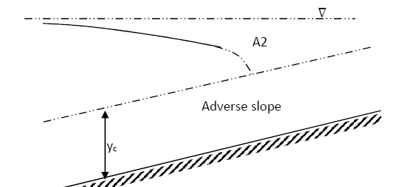

**Fig 4.11 A2-Profile**

**A3-Profile:**

It is a backwater curve which lies in Zone-3 of an adverse sloped channel. As such, the U/S end of A3 profile starts theoretically from the channel bottom while the D/S end of the profile terminates with a hydraulic jump occurs when a super critical flow enters an adverse sloped channel. For example, profile in a stream below a sluice gate provided in an adverse sloped channel.

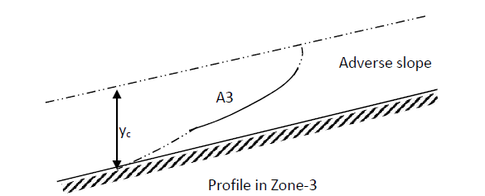

**Fig 4.12 A3-Profile**

**Classifications of surface profile for gradually varied flow:**

|  |  |  |  |  |
| --- | --- | --- | --- | --- |
| Channel type |  | Depth relation | Type of flow | Type of profile |
| Mild | (+)ve |  | Subcritical | M1 Backwater |
| (-)ve |  | Subcritical | M2Drawdown |
| (+)ve |  | Super critical | M3 Backwater |
| Steep | (+)ve |  | Subcritical | S1 Backwater |
| (-)ve |  | Supercritical | S2Drawdown |
| (+)ve |  | Super critical | S3 Backwater |
| Critical | (+)ve |  | Subcritical | C1 Backwater |
| (+)ve |  | Super critical | C3 Backwater |
| Horizontal | (-)ve |  | Sub critical | H2Drawdown |
| (+)ve |  | Super critical | H3 Backwater |
| Adverse | (-)ve |  | Sub critical | A2Drawdown |
| (+)ve |  | Super critical | A3 Backwater |

**Example 4.1:**

A rectangular channel of 5m wide carries water at a depth 1.5m, Sb = 10-4, N= 0.016and ends in a canal drop. The depth upstream at some upstream point is 1.4m. Find the type of profile.

Sol: 



So profile is zone 2 with mild slope. Thus, M2 type profile will occur

**Example 4.2:** The normal depth in a trapezoidal channel of bottom width of 15m, side slope 1H: 1V is 1.5m. The slope is 10-4 and N = 0.02.A weir constructed at downstream raises the water depth 3m immediately upstream of weir. Predict the type of profile.

Sol;





So flow is subcritical, i.e. bed slope will be mild

Again  Therefore, profile is M1 type.



**Direct step method:**

This method was first suggested by charmonskii in 1914. The method is simpler and suitable for field engineers. It gives an approximate profile if done by hand with calculator taking steps i.e. *∆x* a bit bigger. But if a good result is expected, computer program may be written taking *∆x* very small.

From the equation 

Writing in finite difference for,  where  is the average friction slope calculated at  section.



And finally 

Steps of computation:

1. From the given value of Q and other channel parameters like channel section *N,* calculate *yn and yc.* Plot it above channel bottom as shown in figure. Let the profile type in M1 type.
2. Value of *yn* and *yc* will determine the type of profile. Let it be M1 type profile.
3. Let *y*1 be initial depth at control section. Calculated value of *yn* and *yc* indicate the zone of profile and exact type of profile. (Say M1)
4. Approximate surface profile is drawn where it occurs.
5. Calculation may be started step by step.
6. The value of y1 is known.
7. Since M1 is asymptotic to NDL, calculation of L is made between known depths y1 and 1.01 yn (i.e. 1% above yn).
8. Total length L is the summation of *∆x1, ∆x2, ∆x3, ∆x4,………∆xn-1*
9. From y1 at section 1, compute V1, 
10. Assume depth y2 at section 2 at a distance ∆x1. Here for M1 profile y2 at distance *∆x1* is smaller than y1 again calculate V2, 

Apply equation  to calculate *∆x1*

Assume another value of y3 again calculate V3, 

Apply equation  to calculate *∆x2*

Thus assumptions of y4, y5, y6…………….yn =1.01 of normal depth and repeating above steps is made to calculate *∆x3*, *∆x4, ∆5 … ∆xn-1.*

Now, .

**Example 4.1:** A rectangular channel 8m wide carries a discharge of 11m3/s (manning’s N = 0.025, bed slope of 0.016).Compute the length of back water profile created by a dam which backs up a depth 2m immediately behind the dam by direct step method. Take at least 3 steps to compute the profile.

Compute the normal depth of flow by trial and error method or first get yn by approximate direct solution equation. Take this value as the first assumed value for trial and error method.



From trial and error method *yn* = 1.0m L.H.S ≈11m3/s

Critical depth yc 

As  slope is mild, so profile is M-profile. The depth profile near the dam is 2.0m > *yn*

It is in zone 1 so M1 profile.

For computation of the profile length L in three steps depths are assumed as shown in figure at dam section. 1.01yn i.e. 1.01m at upstream. M1 is asymptotic to NDL in between 1.8m and 1.5m as shown in sketch. Next will to compute *∆x1*, *∆x2, ∆x3*corresponding to assumed depths by direct step method equation, i.e.



And this computation is tabulated in the below table

|  |  |  |  |  |  |  |  |  |  |  |  |  |
| --- | --- | --- | --- | --- | --- | --- | --- | --- | --- | --- | --- | --- |
| Y  (m) | A  (m2) | | P(m) | | R =A/P | V=Q/A | V2/2g | E =y+  (V2/2g) | ∆E=  E2-E1 | Sf=(V2N2)  /R(4/3) | Ṡ**f** | Sb- Ṡ**f** |
| 2 | 16 | | 12 | | 1.333 | 0.6875 | 0.012 | 2.012 |  | 0.00020 |  |  |
| 1.8 | 14.4 | | 11.6 | | 1.24 | 0.764 | 0.029 | 1.829 | 0.183 | 0.00026 | 0.00023 | 0.00137 |
| 1.5 | 12 | | 11 | | 1.09 | 0.92 | 0.043 | 1.543 | 0.286 | 0.00046 | 0.00036 | 0.00124 |
| 1.01 | 8.08 | | 10.02 | | 0.807 | 1.37 | 0.097 | 1.107 | 0.436 | 0.00114 | 0.00079 | 0.00082 |
| ∆x=∆E/  ( Sb- Ṡ**f**) | | L (m) | |
|  | | 897.207 | |
| 133.6 | |
| 230.6 | |
| 533.007 | |

Therefore, the total length of the profile L = 897.204m

**Control sections or control points:**

Control section is defined as a section in which fixed relationship between discharge and depth.

Examples are weir, dam, sluice gates and change in slopes.

Control sections are classified into two categories

(i) Downstream control section (ii) Upstream control section

(i) **Downstream control section:**

Sub critical flow is controlled by the downstream control it is located just in front of the obstruction. (such as weir, dam and etc.)

(ii) **Upstream control section:**

Super critical flow is controlled by upstream control and it is located just behind the obstruction. (Such as change in slope).

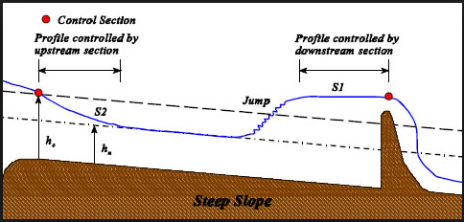

**Upstream & Downstream control sections**

**UNIT 5**

**RAPIDLY VARIED FLOW**

The most common application of the momentum equation in open channel flow  
deals with the analysis of the hydraulic jump. The rise in water level, which occurs during the transformation of the unstable ‘rapid’ or supercritical flow to the stable tranquil” or subcritical flow, is called hydraulic jump. Manifesting itself as a standing wave at the place where the hydraulic jump occurs. A lot of energy of the flowing liquid is dissipated (mainly into heat energy). This hydraulic jump is said to be a dissipater of the surplus energy of the water. Beyond the hydraulic jump the water flows with a eater depth. And therefore with a less velocity.

The hydraulic jump lies many practical and useful applications. Among them are the following:

* Reduction of the energy and velocity downstream of a dam or chute in order to minimize and control erosion of the channel bed.
* Raising of the downstream water level in irrigation channels.
* Acting as a mixing device for the addition and mixing of chemicals in industrial and water and wastewater treatment plants. In natural channels the hydraulic jump is also used to provide aeration of the water for pollution control purposes.

However, before dealing with the hydraulic jump in detail, it is necessary to understand the principle of the so-called specific energy. We will apply this principle for explaining the hydraulic jump phenomenon.

**Hydraulic jump features:**

The following features are associated with the transition from supercritical to subcritical flow:

1. Highly turbulent flow with significantly dynamic velocity and pressure components;
2. Pulsations of both pressure and velocity, and wave development downstream of the jump;
3. Two-phase flow due to air entrainment;
4. Erosive pattern due to increased macro-scale vortex development;
5. Sound generation and energy dissipation as a result of turbulence production.

A hydraulic jump thus includes several features by which excess mechanical energy may be dissipated into heat. The action of energy dissipation may even be amplified by applying energy dissipators.

**Hydraulic jump analysis:**

For mathematical analysis, momentum equation is considered. Energy equation is not taken into consideration as a lot of energy in the jump is lost. By writing the momentum equation considering small reach *Lj* i.e. between two sections 1-1 and 2-2. 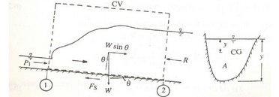

**Fig 5.1Definition sketch of momentum equation**



The following assumptions are required for jump analysis.

1. Length of the jump *Lj* is small as it is RVF, so force of friction or resistance *Ff* is small and neglected.
2. Bed slope θ is very small, hence sinθ ≈ 0 thus W sinθ ≈ 0.
3. Hydrostatic pressures P1 (at 1-1) and P2 (at 2-2) prevail before and after the jump.
4. Flow is uniform before and after the jump i.e. depth *y1* before the jump and depth *y2* after the jump remain constant. Thus, considering the control volume of liquid between 1-1 and 2-2, momentum equation with above assumptions, becomes











The above term on L.H.S is specific force at section 1-1. It is the summation of force per unit weight of water and momentum of the flow passing the channel section per unit time per unit weight of water.

Assume channel is rectangular





For rectangular channel of bottom width B,

 

Multiplying by  











The above equation is in quadratic form, solving for *y2*

 



 





Similarly it is solved for y1



Here, y1 is before the jump

y2 is after the jump

Fr1 Froude’s no. before the jump > 1

Fr2 Froude’s no. after the jump < 1

 is called sequent depth ratio for the initial froude’s number Fr1 in horizontal friction less rectangular channel and is known as Belanger momentum equation. For high value of Fr1 >8 is approximated to be

**Basic characteristics of the hydraulic jump:**

**Loss of energy in jump:** If E1 and E2 are the specific energies before and after the jump then,





The belanger momentum equation is





Substituting this

 From equation we get



It gives the loss of energy in hydraulic jump in rectangular channel.

**Efficiency of the jump:**

The ratio of specific energy after the jump (E2) to the energy before the jump (E1) is defined as the efficiency of the jump.

i.e., Efficiency of the jump = E2 / E1



**Height of the jump:**

The difference between the depths after and before the jump is the height of the jump. It

is denoted by hJ



**Types of hydraulic jump:**

Hydraulic jumps on a horizontal bottom can occur in several distinct forms. Based on the Froude number of the supercritical flow directly upstream of the hydraulic jump, several types can be distinguished.

It should be noted that the ranges of the Froude number given in Table for the various types of jump are not clear-cut but overlap to a certain extent depending on local conditions. Given the simplicity of channel geometry and the significance in the design of stilling basins, the classical hydraulic jump received considerable attention during the last sixty years. Of particular interest were:

The ratio of sequent depths, which is the flow depths upstream and downstream of the jump, and the length of jump, measured from the toe to some tail water zone.

**1. Undular jump:**

Undular jump occurs if Froude’s number at pre-jump in between **1 and 1.7**.The water surface shows undulations and energy dissipation is less than **5%**.

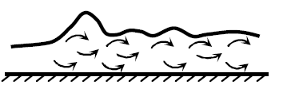

**Fig 5.2 Undular jump:**

**2. Weak jump:**

Weak jump occurs if Froude’s number at pre-jump in between **1.7 and 2.5**. And energy dissipation is varies from **5 to 15%**.A series of small rollers develop on the surface of the jump, but the downstream water surface remains smooth. The velocity throughout is fairly uniform, and the energy loss is low.

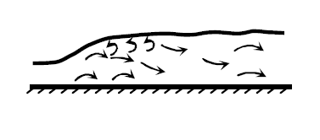

**Fig 5.3 Weak jump:**

**3. Oscillating jump:**

Oscillating jump occurs if Froude’s number at pre-jump in between **2.5 and 4.5**. And energy dissipation is varies from **15 to 45%**.There is an oscillating jet entering the jump from bottom to surface and back again with no periodicity. Each oscillation produces a large wave of irregular period which, very commonly in canals, can travel for meters doing unlimited damage to earthen banks and rip-raps.

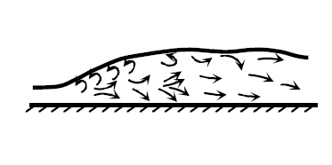

**Fig 5.4 Oscillating jump:**

**4. Steady jump:**

Steady occurs if Froude’s number at pre-jump in between **2.5 and 4.5**.The downstream extremity of the surface roller and the point at which the high velocity jet tends to leave the flow occur at practically the same vertical section. The action and position of this jump are least sensitive to variation in tail water depth. The jump is well-balanced and the performance is at its best. The energy dissipation ranges from **45 to 70%.**

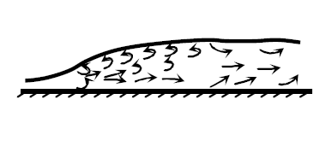

**Fig 5.5 Steady jump**

**5. Strong jump:**

Strong jump occurs if Froude’s number at pre-jump is more than **9.0** The high-velocity jet grabs intermittent slugs of water rolling down the front face of the jump, generating waves downstream, and a rough surface can prevail. The jump action is rough but effective since the energy dissipation may reach 85%.

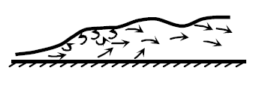

**Fig 5.6 Strong jump**

**Example 5.1:** Water flows under a sluice gate to discharge into a rectangular plain stilling basin having same width as the gate. After contraction of jet, the flow has an average velocity 24m/s and depth of flow 1.8m. Determine (i) sequent depth y2 9ii) height of the jump hJ (iii) length of the jump Lj (iv) loss of energy in the jump (∆E) (v) Efficiency of the jump(E2/E1) (vi) Types of jump expected (vii) ratio of froude’s number.



Using momentum equation for jump analysis











**Surges:**

Whenever there is sudden change in the discharge or depth or both such situations occur, sudden closure of gate. Surge produces increase in depth is called (+) surge. Surge causes decrease in depth is called (-) surge.

**Positive surge moving downstream:**

Consider a sluice gate in a horizontal friction less channel suddenly raised to cause a quick change in the depth and (+) surge moving downstream. The sections (1) & (2) conditions are before and after passage of surge, respectively.

The absolute velocity *Vw* is assumed to be constant. The unsteady flow condition is brought relative steady state by applying velocity (-*Vw)* to all directions. Energy equation can’t be applied but momentum equation is applicable.

By continuity equation



Apply momentum equation















For a rectangular channel, considering unit width of the channel,

The continuity equation



The momentum equation is simplified as



Substituting for V2 and simplifying,



**Example5.1:** A 3.0m wide rectangular channel has a flow of 3.6m3/s with a velocity of 0.8m/s .If a sudden release of additional flow at the upstream end of the channel causes depth rise by 50 percent, determine the absolute velocity of the resulting surge and the new flow rate.

The surge moves in downstream direction and absolute velocity of wave Vw is positive. By superimposing (-Vw) on the system the equivalent steady flow is obtained.

Here,



For a positive surge moving downstream in a rectangular channel



**Positive surge moving upstream:**

This kind of surge occurs on the upstream of the sluice gate when the gate is closed suddenly. The unsteady flow is converted into an equivalent steady flow by super position of velocity *Vw* Suffixes 1 & 2 refer to conditions at sections of the channel before and after the passage of surge respectively.

Consider a unit width of a horizontal, frictionless and rectangular channel.





